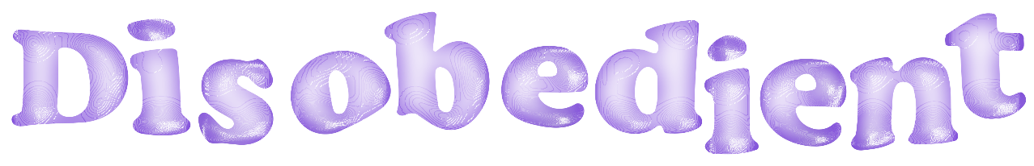

Contribution Form
Please write answers underneath or next to questions. If you have any issue with this form please let us know via the contact information at the bottom.
This is not any type of contract – you retain all rights to your work!

Preferred name–
Pronouns–
Where are you based–
Social media handles (if applicable)-
About you (write about yourself, your studies/job, your inspirations, your art or how you influence your art! This can be as short or as long as you wish - third person is preferable)–
What would you like to contribute? (a run-through of what you’re submitting with some information about that - ie: motivation, meaning, etc)-
Title(s) of contribution(s)–
Genre/medium(s)-

Writing submissions only
Word count (only necessary for submissions to physical issues!)–

Your work may be edited very slightly, and this will mostly just be for formatting reasons, is this ok? (You will see your piece to approve before publication!)–

Do you have any photos/illustrations to go with your piece? (if yes, please tell us who the creator is if not yourself - no problem if you don’t have any!)–

Extra Info
Written submissions can be submitted in PDF, Microsoft Word, Google Doc or just copied and pasted into an email.
They can be in any language but if not in English or Español please send a rough translation with it.

Visual Submissions (photography, illustration etc) only
Please list models, locations and styling information (if applicable)–

Disobedient Online submissions only (podcast, music, short film, etc)

These can be submitted through any format you wish, preferably YouTube/SoundCloud links or if in the format of a feature we can simply link to your content.

Please state locations/cast/crew for videos (if applicable)-

Please state those involved in audio production (if applicable)-

Payment
Currently Disobedient has no funds, therefore, cannot pay our contributors for their work.
This is something we hope to change after the publication of a few physical issues and as interest in contributing increases.
In saying that, photographers who wish to contribute a photo which will be displayed on the front cover of our standard issues will be paid for the use of their image.

You will retain ALL copyright over your own work - Disobedient acts solely as a platform to showcase and promote.

Thank you so much for your contribution, I am truly honoured to be able to publish your work. Physical copies will be able to purchase at a discounted price for contributors.
Contact me at any time if you have any questions.
– Sabrina Sigler (editor)
sigler.sabrina@yahoo.com

disobedientmagazine@gmail.com
https://www.disobedientmagazine.com/

